**[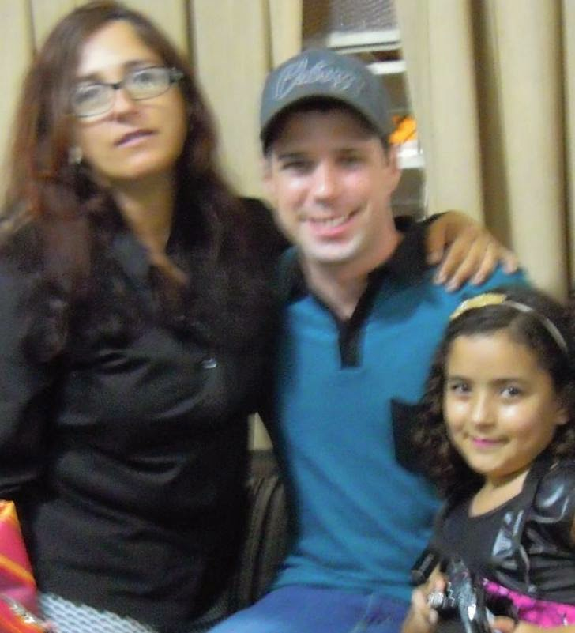](http://1.bp.blogspot.com/--RtC-p8gpTQ/VG3ETc1WeEI/AAAAAAAAAWg/RuM2bq5UvvM/s1600/GARRETT+(4).jpg)**

**Et o cara con camisa azul ? Bandido ?**

**[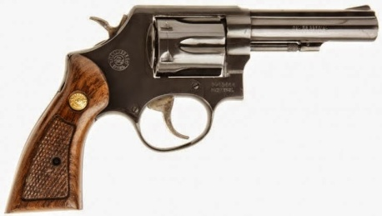](http://4.bp.blogspot.com/-xyZGjXf0C_M/VG3OMcJpqnI/AAAAAAAAAXM/ByYze2riRPc/s1600/Garrett.jpg) + [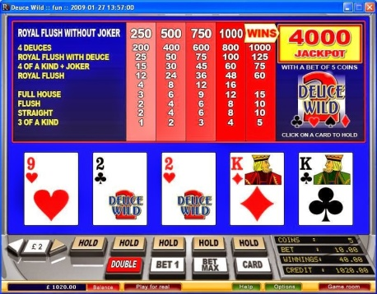](http://4.bp.blogspot.com/-O64UB820ZdQ/VG8qoTsoP0I/AAAAAAAAAZU/_SqqPHFL9bI/s1600/videopoker.jpg) +[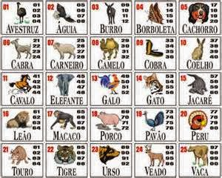](http://3.bp.blogspot.com/-iqzcqpM04U0/VG8mUReMwaI/AAAAAAAAAZA/DFm7oQrYo8I/s1600/thYE8J2CH2.jpg) = [](http://3.bp.blogspot.com/-L2-AGWHaSng/VG8pFjYN7QI/AAAAAAAAAZM/1Eno_yofh8s/s1600/th03Q0JRLY.jpg) +**

**[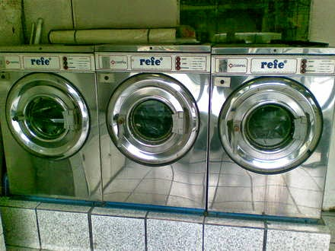](http://1.bp.blogspot.com/-UEOzpTCydN8/VG8kGYnS5gI/AAAAAAAAAY0/FKlyhpyPRn8/s1600/maquinas+de+lavar+roupas+industrial+sao+paulo+sp+brasil__19F795_1.jpg) = [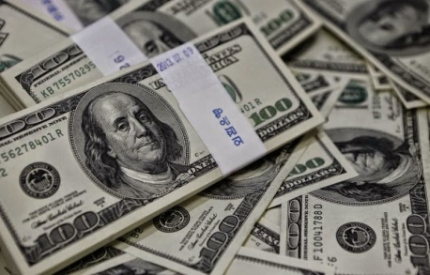](http://2.bp.blogspot.com/-RVbTInmpEjg/VG9fTP61OuI/AAAAAAAAAZw/cYCqUWrAAXM/s1600/american-dollars.jpg)**

**Esse asim o familia mafiosi Garrett.. Que vergona..**

**[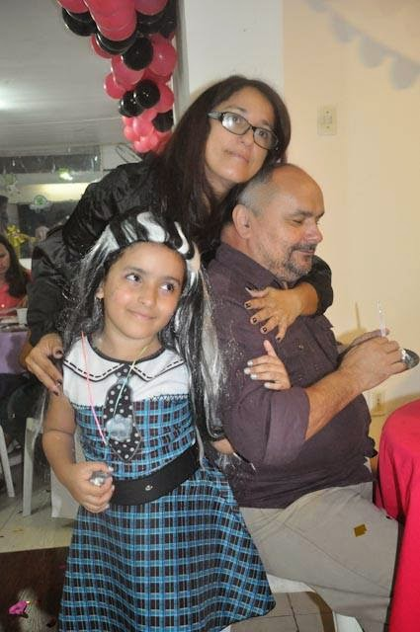](http://4.bp.blogspot.com/-pt51mOautNw/VG3EWbaALWI/AAAAAAAAAWo/TmQxkJPmLjk/s1600/GARRETT+(5).jpg)**

**[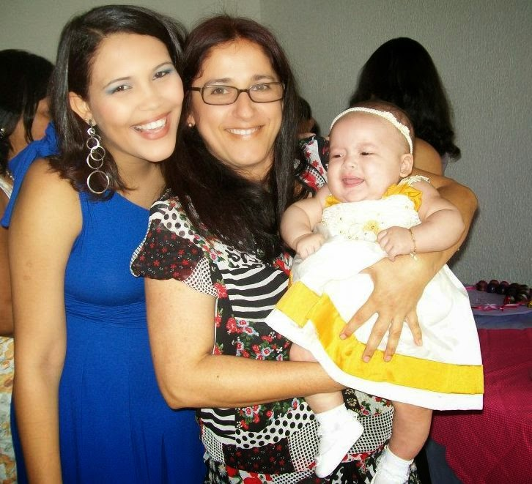](http://4.bp.blogspot.com/-e80eM4ACpv8/VG3EZflVUuI/AAAAAAAAAWw/hVR4Ck1g6Nw/s1600/GARRETT+(6).jpg)**

**[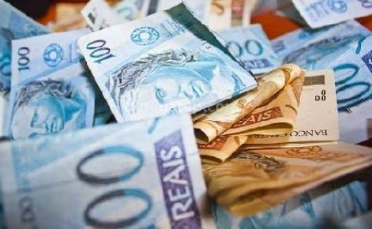](http://1.bp.blogspot.com/-Dkiz1qE5znU/VG3RS5bhXFI/AAAAAAAAAXY/2xOGTYIBHeU/s1600/Brazil-real-currency-image.jpg) [](http://4.bp.blogspot.com/-Qlm51nsJdNw/VG8XsdQYsZI/AAAAAAAAAYY/SNsBTmkdn2k/s1600/GARRETT.jpg)**

**Até quando?**