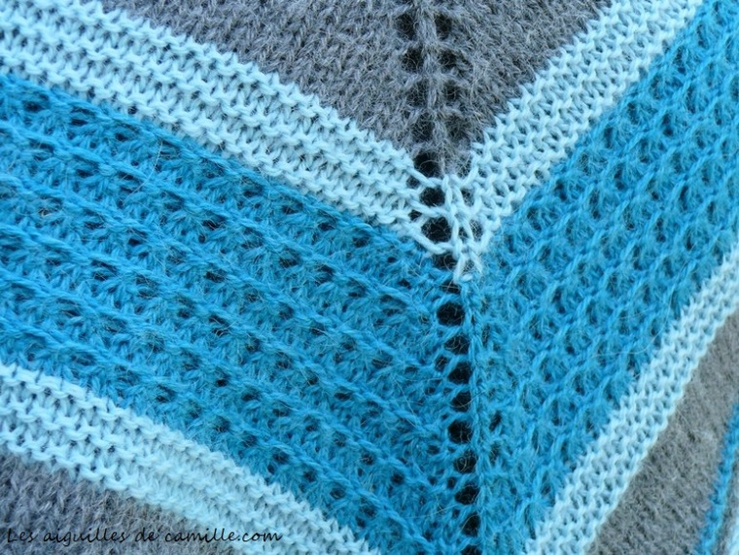
Shawl Facile
Tutorial Step by step
Part 3
Material :
3 balls of Quito Anthracite
2 balls of Quito Turquoise
2 balls of Quito Glacier
Straight needles and/or circular needles 4.5mm
4 stitch markers (tutorial to do them here).
Cisors, a sew or tapestry needle. 1 row counter or a piece of paper to count the rows .
Points and abbreviations :
k : knit
p : purl
Yo: Yarn over, to do a Yarn over followed by a knit stitch, see the tutorial on this page, and to make a Yarn over before a purl stitch, see there.
K2tog: Knit 2 stitches together (see here)
m1: make 1 stitch: knit front loop and back loop of the stitch. Have a look there.
* .... *, Repeat the directions between * and * as many times as necessary to reach the next stitch marker.
M : stitch marker, this marker is not knitting, it slips from one needle to the other according to the indications.
R : row.
k : central stitch , knit it
p: central stitch, purl it.
Note on the central stitch: I indicated in red for you to find easily your way in the indications.
Color 1, C1: Quito anthracite
Color2, C2 : Quito turquoise
Color3, C3: Quito Glacier
Work :
With C1, knit the following rows :
R 1, 3, 5, 7, 9, 11, 13, 15, 17, 19, 21, 23, 25 and 27: k3, M, Yo, *k*, before the stitch marker, make 1 Yo, M, k1, M, Yo, *md*, before the stitch marker, make 1 Yo M,k3.
R 2 to 28 included: k3, M, *p*, M, p1 M, *p*, M, k3.
With C3, knit the 6 following rows :
R 29, 31 and 33: k3, M, Yo, *k*, before the stitch marker, make 1 Yo, M, k1, M, Yo, *md*, before the stitch marker, make 1 Yo M,k3.
R30, 32 and 34: k3, M, *k*, M, p1 M, *k*, M, k3.
With C2 :
R35, 43 and 51: k3, M, Yo, *k*, before the stitch marker, make 1 Yo, M, k1, M, Yo, *md*, before the stitch marker, make 1 Yo M, k3.
R36, 44 and 52: k3, M, p1, then *K2tog* until 2 sts before next marker, p2, M, p1, M, p2, *K2tog* until 1 st before next marker, p1, M, k3.
R37, 45 and 53: k3, M, Yo, k1, *m1* until 2 sts before next marker, k2, Yo, M, k1, M, Yo, k2, *m1* until 1 st before next marker, k1, Yo, M, k3.
R38, 46 and 54: k3, M, *p*, M, p1 M, *p*, M, k3.
R39, 47 and 55: k3, M, Yo, *k*, before the stitch marker, make 1 Yo, M, k1, M, Yo, *md*, before the stitch marker, make 1 Yo M, k3.
R40, 48 and 56: k3, M, p2, then *K2tog* until 1 st before next marker, p1, M, p1, M, p1, *K2tog* until 2 sts before next marker, p2, M, k3.
R41, 49 and 57: k3, M, Yo, k2, *m1* until 1 st before next marker, k1, Yo, M, k1, M, Yo, k1, *m1* until 2 sts before next marker, k2, Yo, M, k3.
R42, 50 and 58: k3, M, *p*, M, p1, M, *p*, M, k3.
Number of stitches row by row shawl Facile Part 3
row | 1 | 3 | 5 | 7 | 9 | 11 | 13 | 15 | 17 | 19 | 21 | 23 | 25 | 27
stitches | 173 | 177 | 181 | 185 | 189 | 193 | 197 | 201 | 205 | 209 | 213 | 217 | 221 | 225
row | 29 | 31 | 33 | 35 | 37 | 39 | 41 | 43 | 45 | 47 | 49 | 51 | 53 | 55 | 57
stitches | 229 | 233 | 237 | 241 | 245 | 249 | 253 | 257 | 261 | 265 | 269 | 273 | 277 | 281 | 285

